**Link:** [**https://www.ni.com/getting-started/set-up-hardware/instrument-control/gpib-enet**](https://www.ni.com/getting-started/set-up-hardware/instrument-control/gpib-enet)

**GPIB Configuration**

Use the following video tutorials or the document below to assist you in completing this task:

[Configuration in Windows](http://zone.ni.com/wv/app/doc/p/id/wv-1648/)

[Configuration in Linux](http://zone.ni.com/wv/app/doc/p/id/wv-1658/)

[Configuration in Mac OS X](http://zone.ni.com/wv/app/doc/p/id/wv-1663/)

MAX utility comes with the NI-488 driver for your GPIB controller. It makes GPIB instrument detection and control easy by providing tools that help you search for connecting instruments, and send and receive communication with your device.

https://www.ni.com/images/gettingstarted/neutral/max-shortcut.png

Open MAX by going to **Start»Programs»National Instruments»Measurement & Automation**.

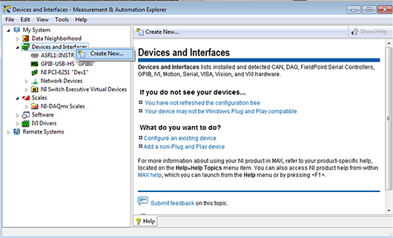

**Figure 5.** MAX Main Menu

To confirm that your GPIB device is connected properly, expand the Devices and Interfaces subdirectory below My System. Then select your GPIB controller. This tutorial uses a USB-GPIB-HS controller. If you are using a PCI, serial, or Ethernet controller/converter, the name may be slightly different. Click on Scan for Instruments.

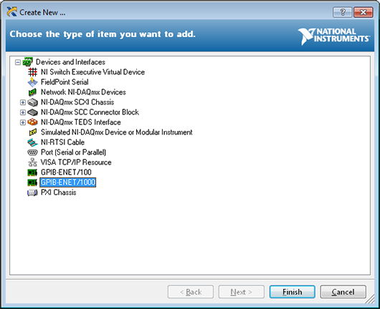

**Figure 6.** Scanning for Instruments in MAX

If your GPIB device is SCPI-compliant, the name and address appear in the lower main window once the instrument scan is complete.

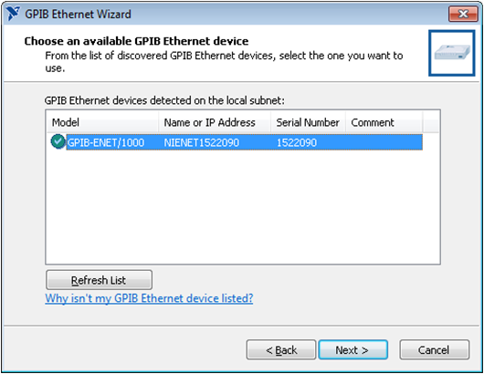

**Figure 7.** GPIB Device Found

If your device did not appear, refer to [GPIB Installation/Configuration Troubleshooter](https://www.ni.com/support/gpib/max/property.htm). Also refer to [KnowledgeBase 1UO68A5P: "Scan for Instruments" Fails in Measurement & Automation Explorer](http://digital.ni.com/public.nsf/allkb/72FAD7156202DDF9862568900048F006?OpenDocument" \t "_blank).

MAX creates the necessary resources for VISA communication with your GPIB instrument. By double-clicking on the identified instrument (in the lower main window of Figure 7), you can access the instrument VISA Properties to change the VISA Resource Name of the device and communicate with it by clicking on Communicate with Instrument (SCPI commands), or Open VISA Test Panel (non-SCPI commands).

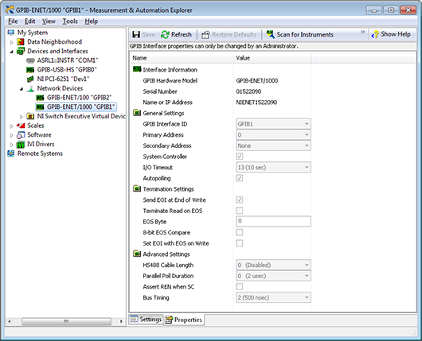

**Figure 8.** Opening VISA Properties Tab

For this example, you entered TDS2024 as your VISA Alias. It is important to choose an alias that you can immediately identify with the intended instrument. This is especially important for large systems featuring many instruments.

**Using the VISA Interactive Control to Confirm Communication and More**

The VISA Interactive Control (VISAIC) is a standard software utility included with NI GPIB controller products. Using your computer, you can take advantage of this powerful development and debugging tool to interactively communicate (read, write, serial poll, and so on) with your GPIB instruments. With the VISAIC utility, you can speed up application development by learning how to automate measurements with your instruments, uncover GPIB problems, and avoid headaches by identifying malfunctioning instruments. For Windows platforms, the VISAIC utility comes with online help that describes the applicable NI-488 functions and NI-488.2 routines, syntax, error codes, and status variables offer with the debugging information you need to solve problems.

For a detailed discussion on how to use the VISAIC utility and the functions in the examples, refer to the VISA help file and NI-488.2 help file, respectively, that came with your GPIB controller. The following sections assume a basic knowledge of the VISAIC utility and GPIB.

To launch VISAIC, click on Tools»NI-VISA»VISA Interactive Control (see Figure 9).

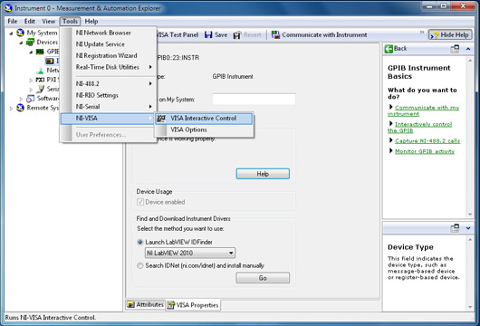

**Figure 9.** Launch VISAIC

**Quickly Determining GPIB Addresses**

When VISAIC initially runs, it automatically finds all of the available resources in the system and lists the instrument descriptors for each resource under the appropriate resource type. Figure 10 shows the VISAIC opening window.

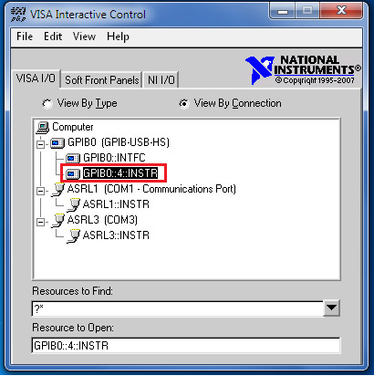

**Figure 10.** VISA Interactive Control

Instruments must be powered on and connected to the GPIB controller to be recognized. If you have two or more instruments on the bus, you can disconnect all instruments except one to determine its address. By isolating each instrument on the bus and repeatedly refreshing (View»Refresh), you can quickly determine the address of each instrument. You also can use the Resource to Find field to query each instrument for an identification (ID) string. ID querying is discussed in the next section.

**Establishing Communication With Your Instruments**

Once you have determined the GPIB address of your instruments, it is easy to establish communications to verify that you can send and receive data to and from the instrument. Because most instruments are compliant with 488.2, you can query the instrument for its identification by sending it the \*IDN? command. Instruments typically respond with the manufacturer's name, model name, and various alphanumeric characters that the manufacturer uses to track firmware revisions. To communicate with your instrument at Address 4, follow these instructions:

First, double-click the instrument in the VISAIC that you want to communicate with—in this case, GPIB0 ::4::INSTR.

This opens a VISA Test Panel for your instrument. With this test panel, you can set properties for your instrument communication as well as read and write to the instrument.

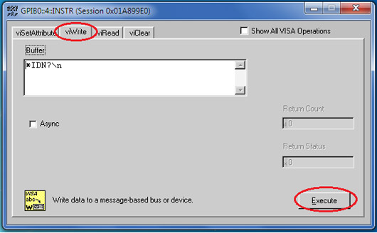

**Figure 11.** VISA Test Panel (viWrite)

This opens a VISA Test Panel for your instrument. With this test panel, you can set properties for your instrument communication as well as read and write to the instrument.

Now from the viRead tab, select a count of 100, the length of your expected response, and then click Execute to return an identification string.

You have just confirmed communication with your instrument. You can repeat this process to confirm communication with all of your connected instruments.

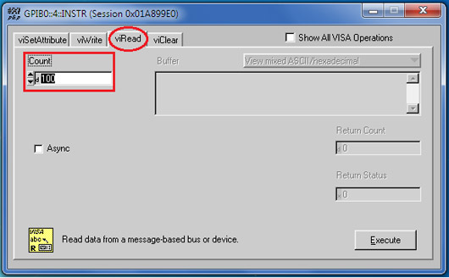

**Figure 12.** VISA Test Panel (viRead)